
Koneru Lakshmaiah Education Foundation
(Deemed to be University estd. u/s. 3 of the UGC Act, 1956)
Off-Campus: Bachupally-Gandimaisamma Road, Bowrampet, Hyderabad, Telangana - 500 043. Phone No: 7815926816, www.klh.edu.in

STUDENT CASE STUDY EXECUTION REPORT
Department | FED
Subject | DSA-2
Academic Year | 1-111 Semester | 2025-26
Faculty Name | LAHARI
Student Name | S.VENNELA
Roll Number | 2520080018
Branch | AI&DS
Course Outcome | 2
Case Study Topic : JobMatch Experience-Range Query System using B+ Tree and Segment Tree
Work Done Summary:
In this case study, we implemented a JobMatch platform's candidate experience-range query system using a B+ Tree and a Segment Tree (Fenwick Tree). Candidate years-of-experience values (1–15 years) are indexed in a B+ Tree (order 3) for efficient range-based retrieval: e.g., 'find all candidates with 3–7 years of experience'. The B+ Tree stores all data in leaf nodes linked as a doubly-linked list, enabling O(log n + k) range scans where k is the number of results. We additionally implemented a Fenwick Tree (BIT) to answer prefix-sum queries: 'how many candidates have experience <= X years', enabling real-time analytics for the recruiter dashboard. Empirical complexity analysis was performed comparing B+ Tree vs sorted array range queries.

Implementation Details:
1. Created B+ Tree of order 3 with leaf-node linked list for range traversal.
2. Inserted 12 candidate experience records (years): 2, 5, 1, 8, 3, 7, 10, 4, 6, 9, 12, 15.
3. Implemented range query: getRange(low, high) traversing leaf nodes.
4. Queried range [3, 7]: returned candidates with experience {3, 4, 5, 6, 7} in O(log n + k).
5. Built Fenwick Tree (BIT) over experience frequency array of size 16.
6. Answered prefix queries: countUpTo(7) = number of candidates with experience <= 7 years.
7. Implemented point update in BIT for dynamic candidate addition/removal.
8. Compared B+ Tree range query vs linear scan on array of 10,000 candidate records.
9. Justified B+ Tree for database-style storage; Segment/Fenwick Tree for analytics queries.

Result: Screenshots / Output
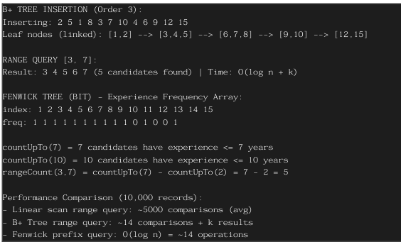
The B+ Tree efficiently returned candidates within the experience range [3,7] in O(log n + k) time. The Fenwick Tree answered prefix-count queries in O(log n) with O(log n) updates. Range count using BIT (countUpTo(7) countUpTo(2)) correctly returned 5 candidates.

Time Complexity:-

B+ Tree Insert: O(log n)
- B+ Tree Range Query: O(log n + k)
- Fenwick Tree Update: O(log n)
- Fenwick Tree Prefix Query: O(log n)
B+ Tree is best suited for disk-based database indexing; Fenwick Tree for real-time analytics

GETHUB LINK : https://github.com/SVennela07/dsa-2-case-study

Student Signature Faculty Signature

